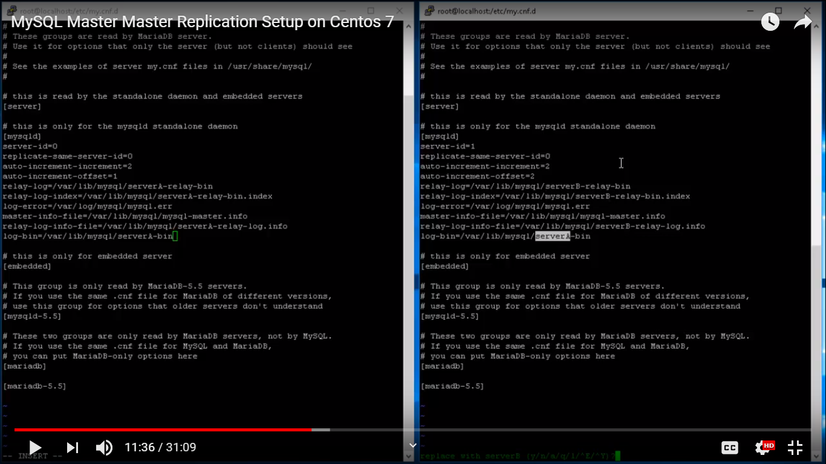

Note: Server id -1 (first server) and server id-2 for second server

After configuration

Service restart